**Name: JOBIN TJ**

**Roll No:7**

**Batch:MCA-B**

**Date:8/04/2022**

**ADVANCED DBMS LAB**

**Experiment No.: 2**

**Aim**

To familiarize with selecting data from single table

**QUESTION**

1. List all data from table deposite

**PROCEDURE**

SELECT*FROM DEPOSIT;

**OUTPUT**

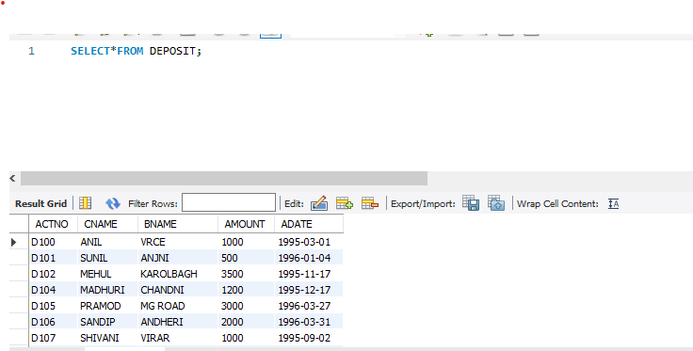

**QUESTION**

2. List all data from borrow

**PROCEDURE**

SELECT*FROM BORROW;

**OUTPUT**

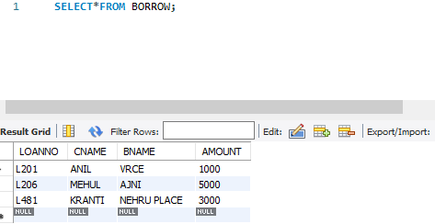

**QUESTION**

3. List all data from customer

**PROCEDURE**

SELECT*FROM CUSTOMER;

**OUTPUT**

**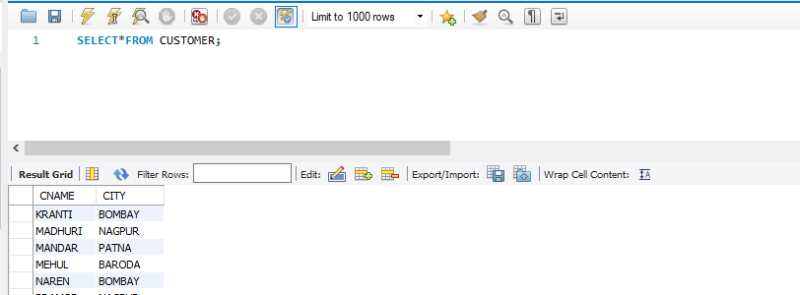  
QUESTION**

4. List all data from branch

**PROCEDURE**

SELECT*FROM BRANCH;

**OUTPUT**

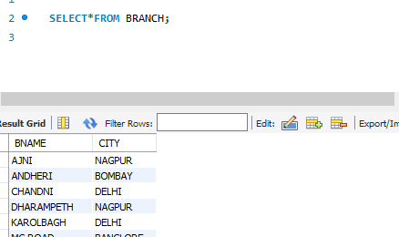

**QUESTION**

5. Give account no and amount of deposite

**PROCEDURE**

**.**SELECT ACTNO,AMOUNT FROM MYACCOUNT.DEPOSIT;

**OUTPUT**

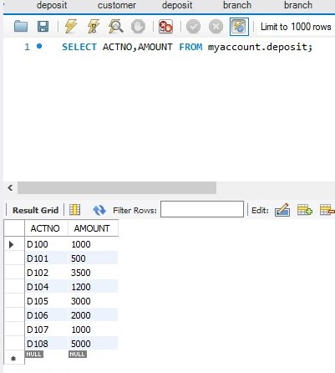

**QUESTION**

6. Give customer name and account no of depositors

**PROCEDURE**

SELECT CNAME,ACTNO FROM MYACCOUNT.DEPOSIT;

**OUTPUT**

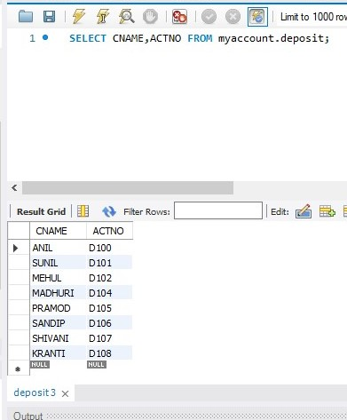

**QUESTION**

7. Give name of customers

**PROCEDURE**

SELECT CNAME FROM CUSTOMER;

**OUTPUT**

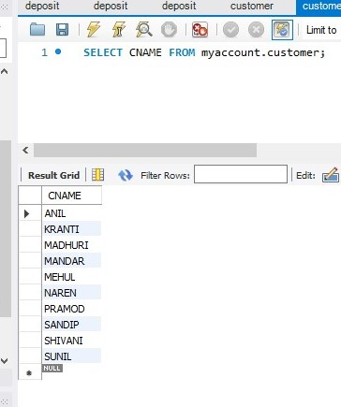

**QUESTION**

8. Give name of branches

**PROCEDURE**

SELECT BNAME FROM BRANCH;

**OUTPUT**

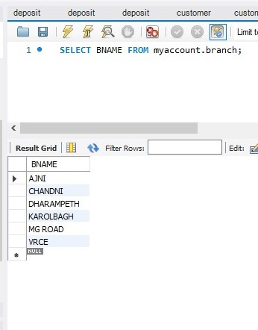

**QUESTION**

9. Give name of borrows

**PROCEDURE**

SELECT CNAME FROM MYACCOUNT.BORROW

**OUTPUT**

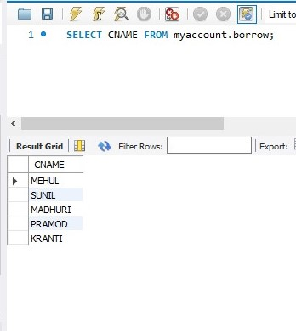

**QUESTION**

10. Give names of customer living in city Nagpur

**PROCEDURE**

SELECT CNAME FROM MYACCOUNT.CUSTOMER WHERE CITY='NAGPUR';

**OUTPUT**

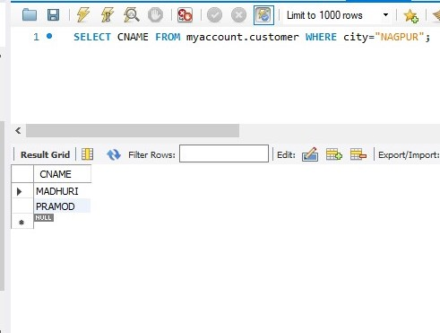

**QUESTION**

11. Give names of depositors having amount greater than 4000

**PROCEDURE**

SELECT CNAME FROM MYACCOUNT.DEPOSIT WHERE AMOUNT>4000;

**OUTPUT**

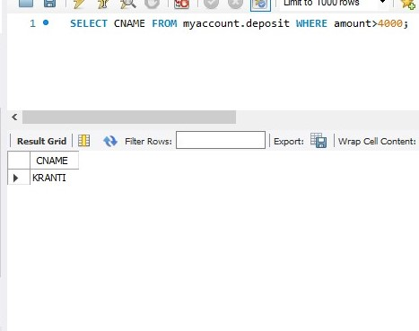

**QUESTION**

12. Give account date of Anil

**PROCEDURE**

SELECT ADATE FROM MYACCOUNT.DEPOSIT WHERE CNAME='ANIL';

**OUTPUT**

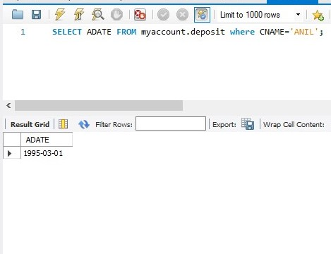

**QUESTION**

13. Give name of all branches located in Bombay

**PROCEDURE**

SELECT BNAME FROM MYACCOUNT.BRANCH WHERE CITY='Bombay';

**OUTPUT**

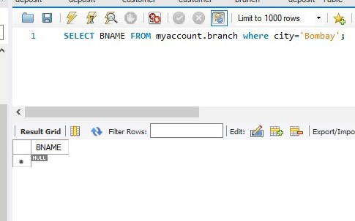

**QUESTION**

14. Give name of borrower having loan number l206

**PROCEDURE**

SELECT CNAME FROM MYACCOUNT.BORROW WHERE LOANNO='L206';

**OUTPUT**

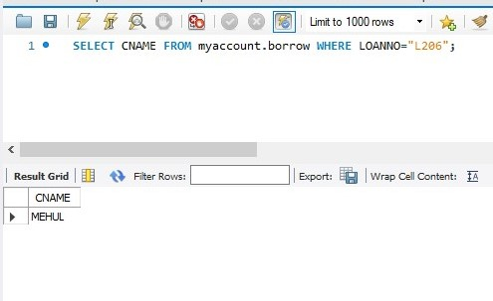

**QUESTION**

15. Give names of depositors having account at VRCE

**PROCEDURE**

SELECT CNAME FROM MYACCOUNT.DEPOSIT WHERE BNAME='VRCE';

**OUTPUT**

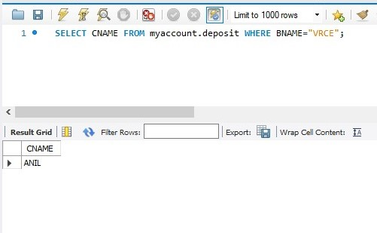

**QUESTION**

16. Give names of all branched located in city Delhi

**PROCEDURE**

SELECT BNAME FROM MYACCOUNT.BRANCH WHERE CITY='Delhi';

**OUTPUT**

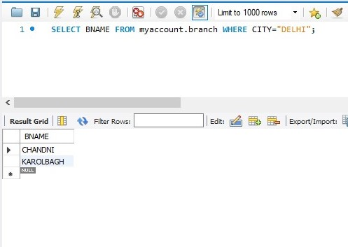

**QUESTION**

17. Give name of the customers who opened account date ‘31-03-96’

**PROCEDURE**

SELECT CNAME FROM MYACCOUNT.DEPOSIT WHERE ADATE='1996-03-31';

**OUTPUT**

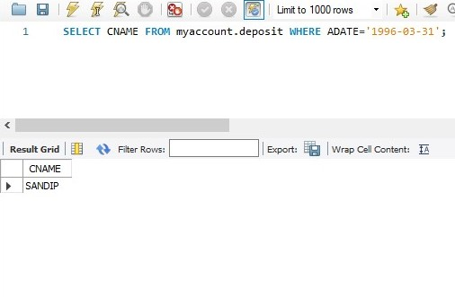

**QUESTION**

18. Give account no and deposit amount of customers having account opened between dates ‘01-01-96’ and ‘1-5-96’

**PROCEDURE**

SELECT ACTNO,AMOUNT from MYACCOUNT.DEPOSIT WHERE ADATE BETWEEN '1996-01-1' AND '1996-05-01';

**OUTPUT**

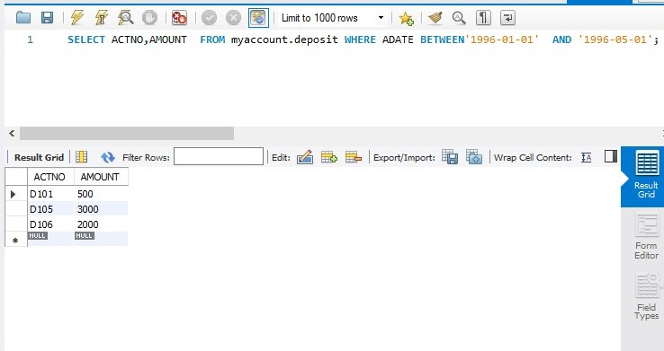

**QUESTION**

19. Give name of the city where branch KAROLBAGH is located

**PROCEDURE**

SELECT CITY FROM MYACCOUNT.BRANCH WHERE BNAME='KAROLBAGH';

**OUTPUT**

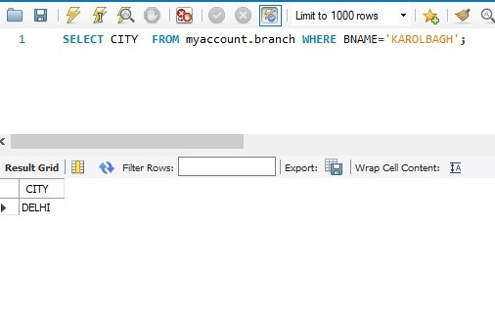

**QUESTION**

20. Give details of customer MEHUL

**PROCEDURE**

SELECT * FROM MYACCOUNT. CUSTOMER join BORROW on CUSTOMER.CNAME= BORROW. CNAME join MYACCOUNT. DEPOSIT on DEPOSIT. CNAME = BORROW. CNAME WHERE MYACCOUNT. CUSTOMER CNAME ='MEHUL'

**OUTPUT**

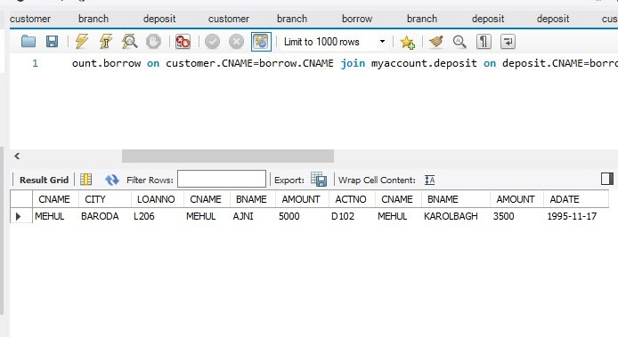

**`**

1. **Borrow (Create and Insert)**

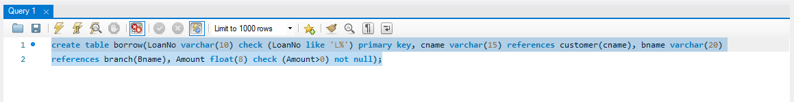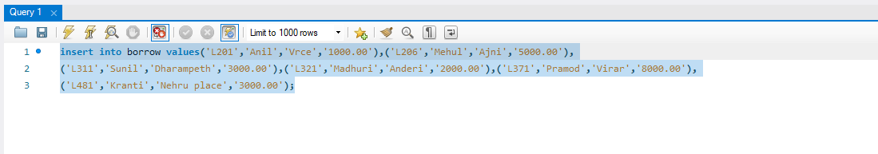

1. **Deposit (Create and Insert)**

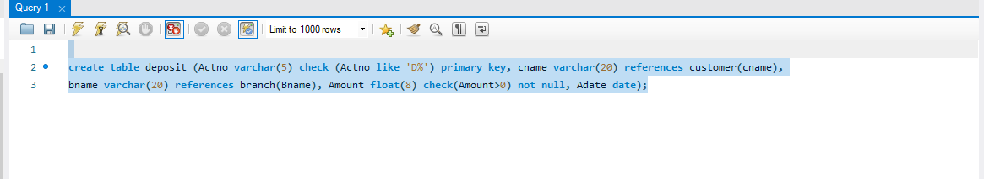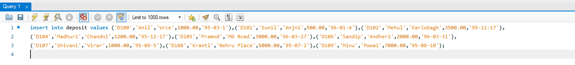

**Output Screenshot**

1. **Customer Table**

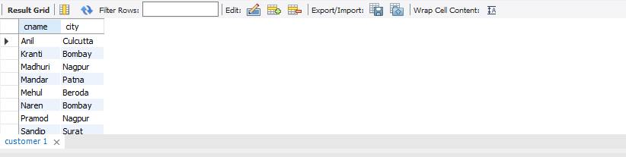

1. **Branch Table**

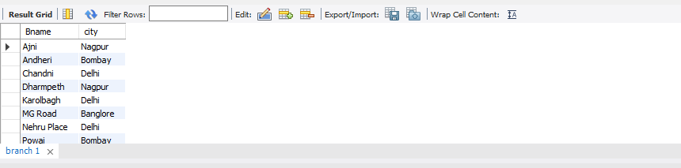

1. **BORROW TABLE**

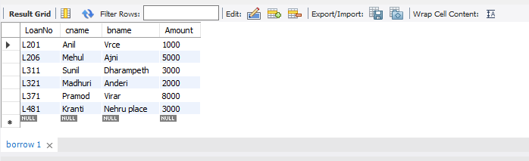

1. **DEPOSIT TABLE**

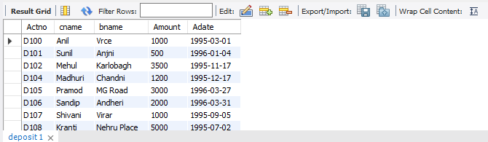

**QUESTION**

9. Give name of borrows

**PROCEDURE**

SELECT CNAME FROM MYACCOUNT.BORROW

**OUTPUT**

